Project handbook
Wetterstation
001

Version 9
Project manager: Matthias Brückl
Date: 10/03/26

Content

1 Project plans 5
1.1 Project Assignment 5
1.2 Project Objectives (objectives, non-objectives) 6
1.3 Description of Pre- and Post Project Phase 7
1.4 Project Environment Analysis 8
1.5 Relationship to Other Projects and the Organisations´s Strategy 9
1.6 Project Organisation Chart 10
1.7 Plan of Objects of Consideration of the Project 11
1.8 Work Breakdown Structure (WBS) 12
1.9 Project Work-Package Specification 13
1.10 Project Responsibility Matrix 14
1.11 Milestoneplan 15
1.12 Project Bar Chart 16
1.13 Resource Plan 17
1.14 Project Cost Plan 18
1.15 Project Communication 19
1.16 Project „Rules“ 20
1.17 Project Risk Analysis 21
1.18 Project Documentation 22
2 Project Start 23
2.1 Minutes– Project Start 23
3 Project Co-ordination 24
3.1 Approval of Work-packages 24
3.2 Minutes – Project Co-ordination 24
4 Project Controlling 25
4.1 Project Status Report 25
4.2 Additional Project Status Reports 26
4.3 Minutes – Project controlling 26
5 Project Close Down 27
5.1 Project Close Down Report 27
5.2 Minutes – Project Close Down 28

Document versions

Versionno. | Date | Change | Author
1 | 24.11.25 | Start | Brückl M.
2 | 28.11.25 | Objectives and project organization completed | Aistleitner D.
3 | 29.11.25 | Completion till 1.5 | Bergbauer K.
4 | 30.11.25 | Completion till 1.9 | Bergbauer K.  Aistleitner D.
5 | 01.12.25 | Updateing 1.4 and 1.9 | Aistleitner D.
6 | 02.12.25 | Finishing the Parts for Project Handbook Part 1 up to 1.10 | Brückl M.
7 | 24.01.26 | Optimizing project environment graphic | Bergbauer K.
8 | 25.01.26 | Update according the feedback | Brückl M.
9 | 01.02.26 | Update according the feedback and complete 1.13 to 2 | Brückl M.
10 | 02.02.26 | First Weekly Report | Bergbauer K.
11 | 16.02.26 | Weekly Report + Update according the feedback | Brückl M.
12 | 11.03.26 | Weekly Report + Update according the feedback | Aistleitner D.
13

Distribution list

Name | Organisational Unit | Role in project | Telephone | E-mail
Brückl Matthias | Project Manager | Backend Developer | 0664 994484299 | Matthias.brueckl@htl-  wels.at
Berbauer Klaus | Project Team Member | Hardware and 3d Modelling | 0677 641591985 | Daniel.aistleitner@htl-  wels.at
Aistleitner Daniel | Project Team Member | Frontend Developer | 0660 90940434 | Klaus.bergbauer@htl-  wels.at
HTl-Wels | Project Owner |  | 0664123456789 | office@htl-wels.at
Smart-Wand | Stakeholder | Help with optimizing | 0681 108468979 | Paul.auer@htl-wels.at
Smart Flowerpot | Stakeholder | Help with optimizing | 0677 632238199 | Thomas.toferer@htl-wels.at

Project plans

Project Assignment

Wetterstation  001 | PROJECT-  ASSIGNMENT
Project start event:  - Submission of the Project shandbook |  | Project start date:  - 12.01.2026
project close down event in terms of content:  - Active usage of the weatherstation  Formal project close down event:  - Handing the weatherstation over to the teacher |  | Project close down dates:  - 10.06.2026
Project objectives:  - Functioning weather station  - Energy-independent power supply  - Web based data analyse  - Minimalist Case |  | Non-objectives:  - No complex data processing  - No guarantee of absolute accuracy of the  - measurement data.  - No use of cloud storage (e.g., Google Drive, AWS,  - Azure).  - No failover protection through redundant hardware  - components.  - No remote control
Main tasks (Project phases):  - Conding Frontend  - Read out the date of the sensors  - Coding a small database  - Coding APIs  - 3d modelling the Case |  | Project resources and costs*:
 |  |  | resource/type of cost | unit |  | Costs (€)
 |  |  | Raspberry Pi 2w / A  BME280 / A  DHT22 / A  VEML6075 / A  Breadboard / A  PETG-Filament / A | 1  1  1  1  1  3 |  | 30€  5€  8€  10€  5€  45€
Project owner:  - Htl Wels |  | Project manager:  - Brückl Matthias
Project team members:
- Aistleitner Daniel
- Bergbauer Klaus

HTL Wels, (Project owner) Matthias Brückl (Project manager)

* Possible categories of total Project budget:
Category A: up to 0,3 million Euro
Category B: up to 1 million Euro
Category C: up to 10 million Euro
Category D: more than 10 million Euro

Project Objectives (objectives, non-objectives)

Wetterstation  001 |  | PROJECT  OBJECTIVES
Type of objective | Project objectives |  | Adjusted project objectives as of...
objectives:  - Main objectives  - Additional objectives | - Readout following sensors:  - UV sensor  - Temperature sensor  - Air pressure sensor  - Humidity sensor  - Energy-independent power supply  - (24 hours 7 days per week)  - Web based data analyse  - Minimalist Case
Non-objectives | - No complex data processing  - No guarantee of absolute accuracy of the measurement data.  - No use of cloud storage (e.g., Google Drive, AWS, Azure).  - No failover protection through redundant hardware components.  - No remote control |  | - If there is enough time left before end of mai this objective could be transformed into an additional object.

Description of Pre- and Post Project Phase

Wetterstation  001 |  | DESCRIPTION OF  PRE- AND POST-  PROJECT PHASE
- Pre-project phase
What triggered the project?
- An assignment for ITP in school
- The idea of the project was given to us by Brückl’s mom
- She wants to know the exact temperature in her garden

Relevant documents for the project („Minutes“, … ONLY documents and no content necessary)
- Weatherstation_Goals.docx
- Materiallist.docx
- Wetterstation_Pflichtenheft.docx
- Protokoll.docx

Experience from similar projects
- Groupwork SEW in second class (Aistleitner/Brückl/Bergbauer)
- Built a react Website (Brückl)

- Post-project phase
What will happen after the project has ended? (follow-up activities, further projects, …)?
- Project will be presented on the “Open House Day” at School

Project Environment Analysis

Wetterstation  001 | PROJECT ENVIRONMENT GRAPHIC
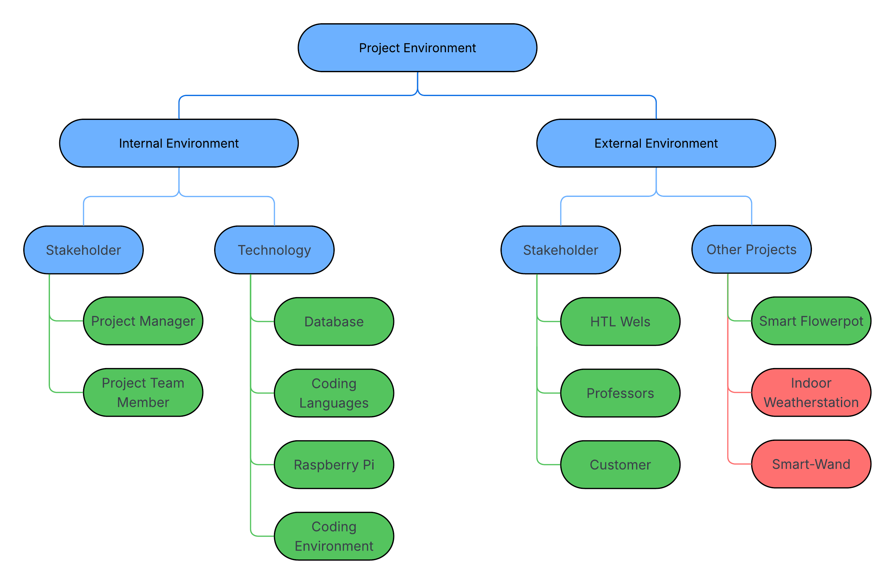

Wetterstation  001 |  | PROJECT ENVIRONMENT  TABLE
Environment | Relationship  (potential/conflict) |  | Measures |  | Who / when  PSP Code
Stakeholder | potential |  | Can help us to optimize our project |  | HTL-Wels/  Professors
Other Projects | potential |  | can help each other |  | Smart-Flowerpot/  Smart-Wand
Technology | potential |  | help us to implement it as we envision it |  | Database/Coding  languages/  Raspberry Pi
Other Projects | conflict |  | Are competition |  | Indoor  Wetterstation

Relationship to Other Projects and
the Organisations´s Strategy

Wetterstation  001 |  | RELATIONSHIP TO OTHER PROJECTS
Programs/  Projects/ | Relationship  (potential/conflict) |  | Sanctions | Who / when  WBS Code
Indoor-  Wetterstation | Conflict |  | Competition | Paul Gnadlinger;  Nicolas Goiginger
Smarter Blumentopf | Potential |  | Support with Know-how | Paul Auer
Smart-Wand | Potential |  | Support with Know-how | Thomas Toferer

Wetterstation  001 |  | CONNECTION TO THE  ORGANISATION´S STRATEGY
Strategy | Description of connection/relationship
- | -

Project Organisation Chart
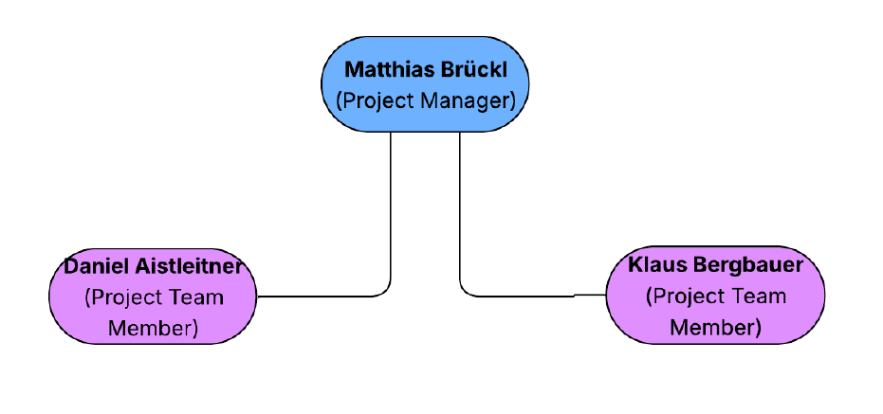

Wetterstation  001 |  | PROJECT-  ORGANISATION
Role in Project | Field of duties/Skills |  | Name
Project owner | Financial providence |  | HTL Wels
Project manager | Backend development |  | Matthias Brückl
Project team members | 1. Frontend development  2. Hardware and 3d Modelling |  | 1) Daniel Aistleitner  2) Klaus Bergbauer
Project members

Plan of Objects of Consideration of the Project

Wetterstation  001 | PLAN OF OBJECTS OF CONSIDERATION
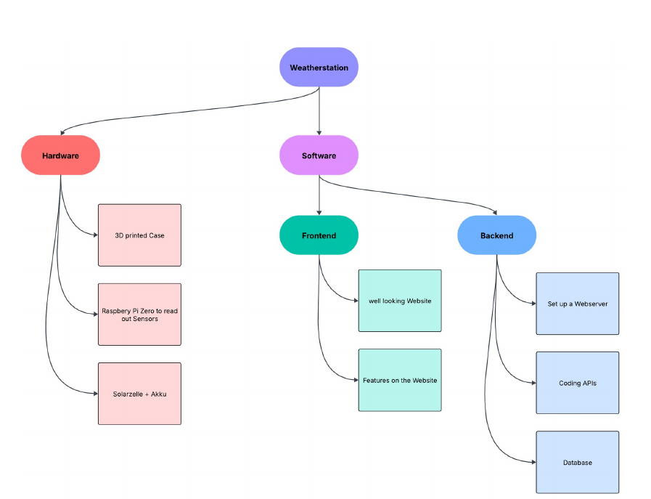

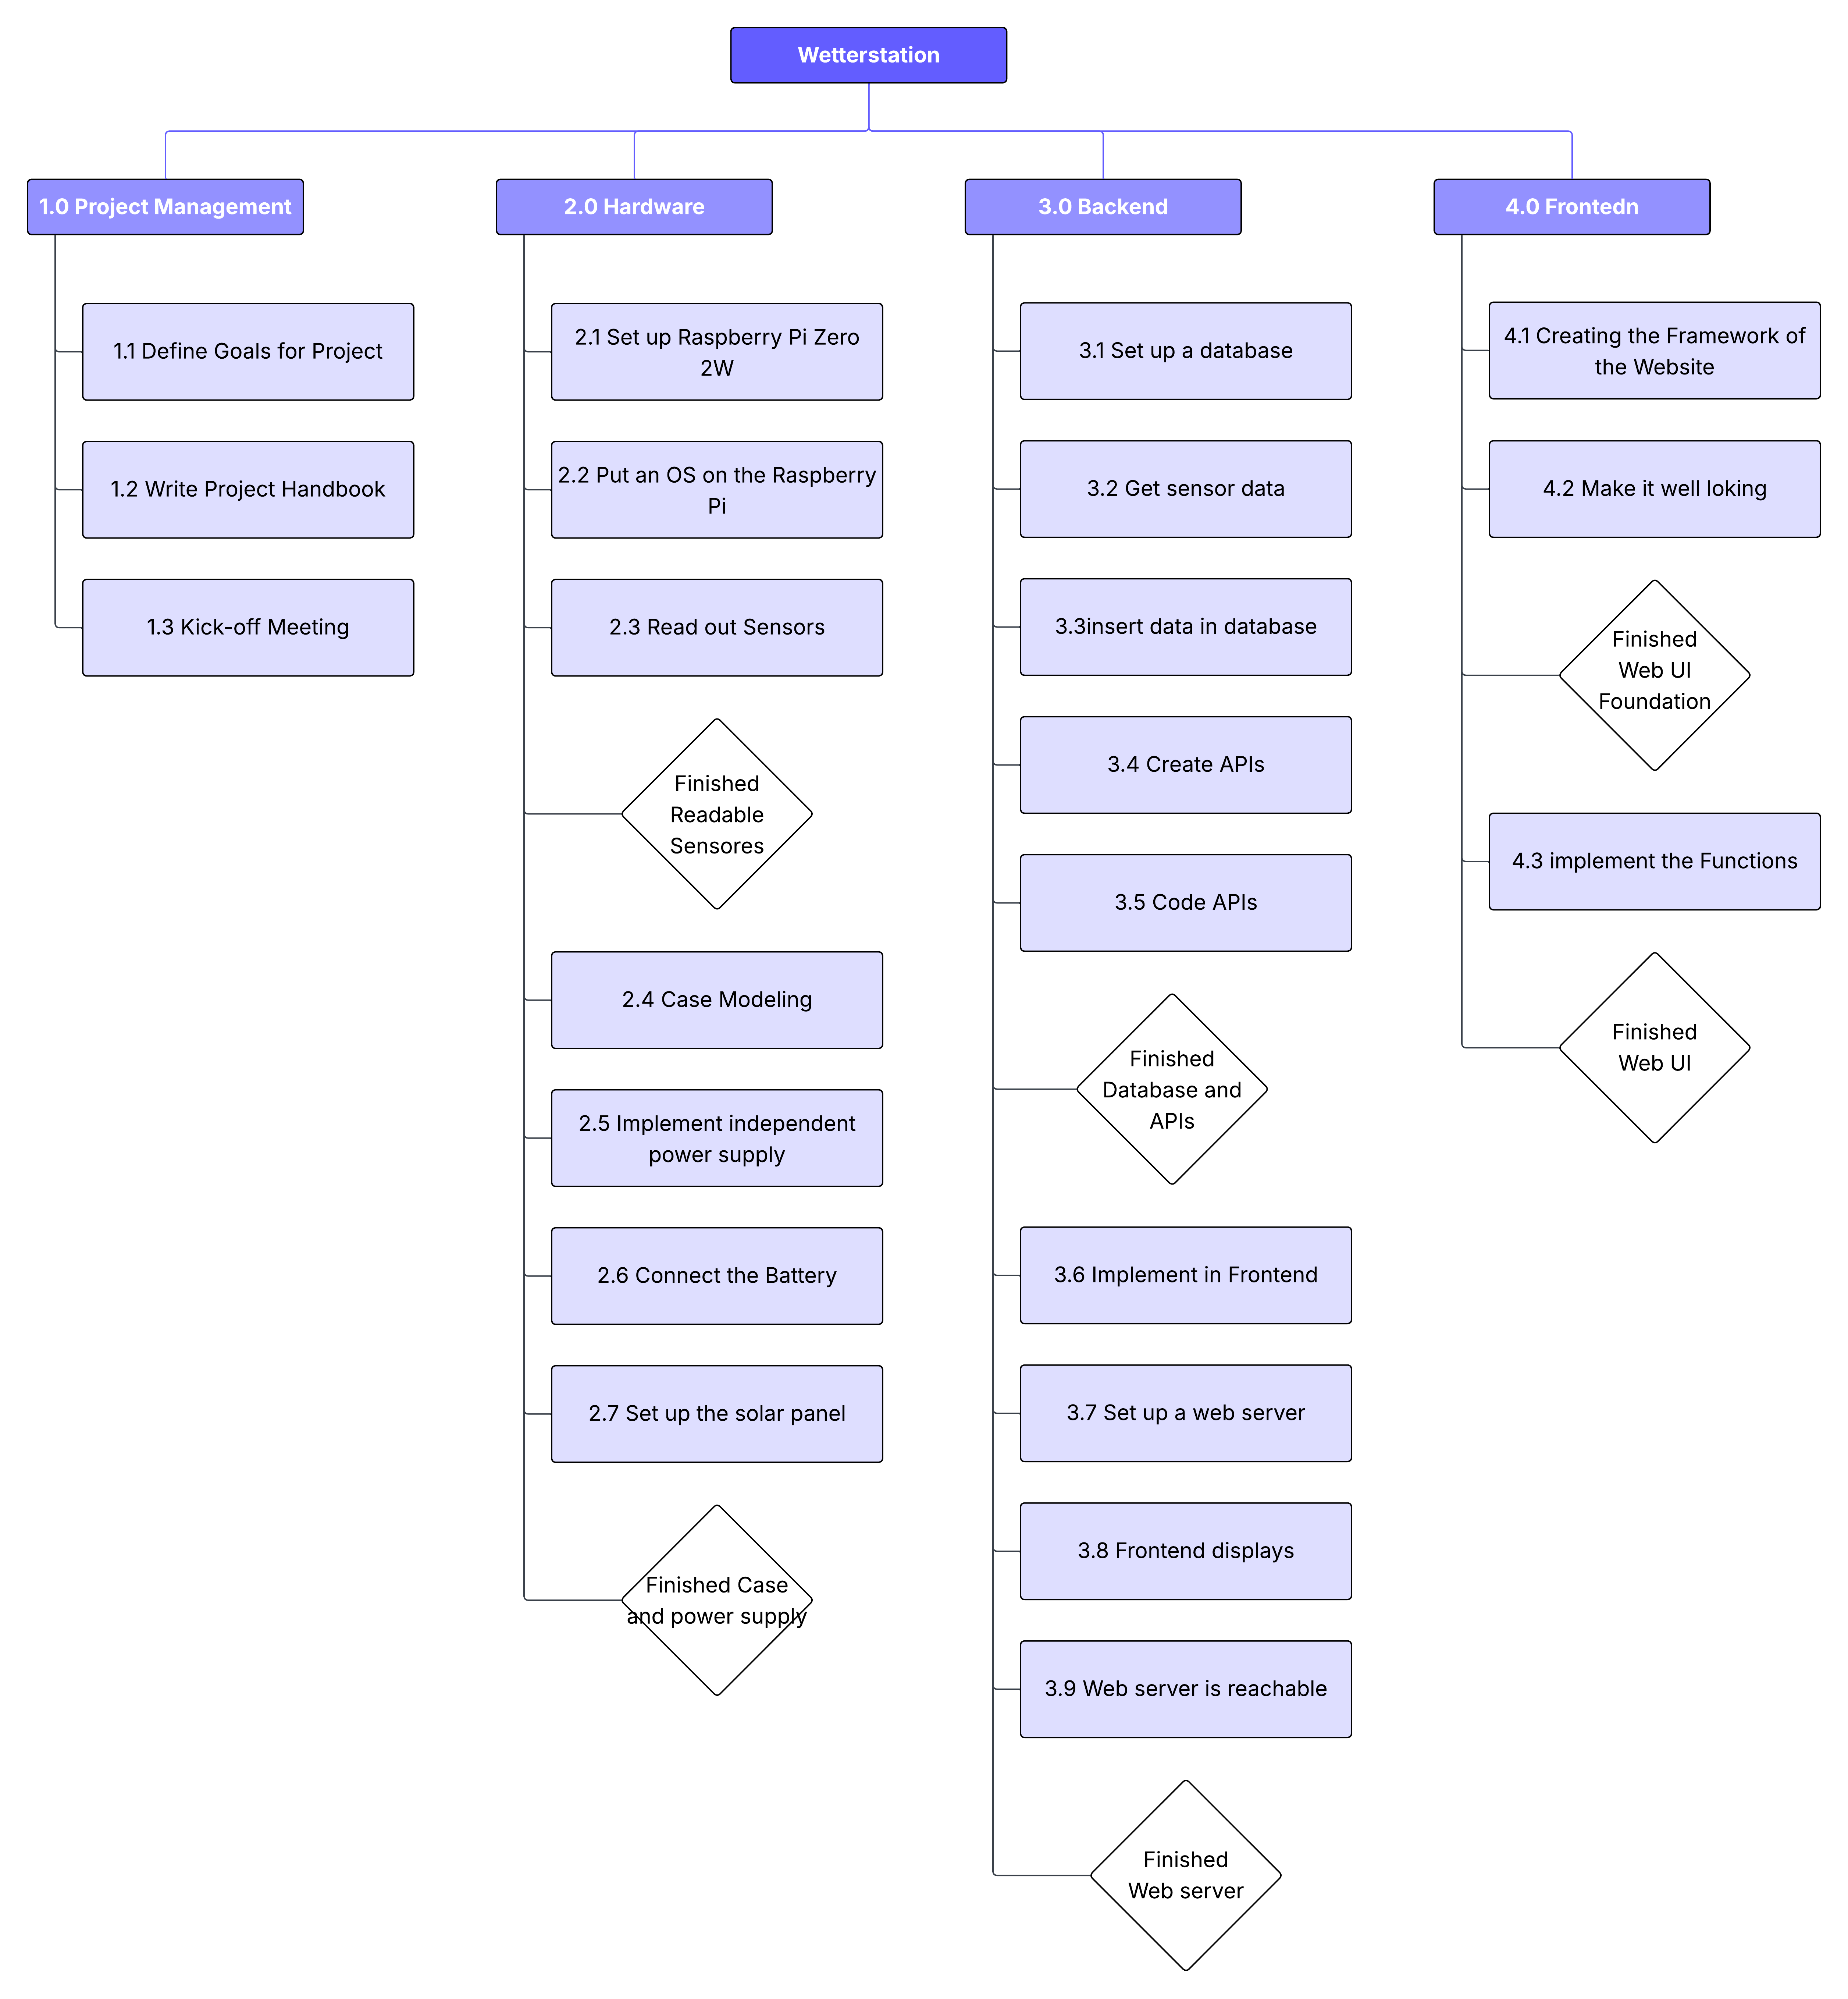
Work Breakdown Structure (WBS)

Project Work-Package Specification

Wetterstation  001 |  | PROJECT WORK-PACKAGE SPECIFICATION
1.1 Setup a Folder Structure | WP Content (What shall be done?)  - Think about a clear folder structure
WP Result (What is achieved after WP was finished?)
- Have a clear folder structure

Progress Measurement (How is progress measured?)
- Every File has his right place
1.2 Workout Project Requirements | WP Content (What shall be done?)  - Think about the Project Requirements
WP Result (What is achieved after WP was finished?)
- Have a clear vision of the Project

Progress Measurement (How is progress measured?)
- The Requirements willincrease
1.3 Workout Project Handbook section  1-3 | WP Content (What shall be done?)  - Filling the Project-Handbook
WP Result (What is achieved after WP was finished?)
- The sections 1-3 have the right entries

Progress Measurement (How is progress measured?)
- The Project-Handbook are filling
1.4 Workout Project Handbook section  4-5 | WP Content (What shall be done?)  - Filling the Project-Handbook section 4-5
WP Result (What is achieved after WP was finished?)
- The sections 4-5 have the right entries

Progress Measurement (How is progress measured?)
- The Project-Handbook are filling
1.5 Workout Project Specification Section | WP Content (What shall be done?)  - Filling the Project Specification
WP Result (What is achieved after WP was finished?)
- Have a clear Project Specification, which has the right entries

Progress Measurement (How is progress measured?)
- The Project Specification are filling
2.1 Raspberry activation | WP Content (What shall be done?)  - Setting up the raspberry
WP Result (What is achieved after WP was finished?)
- Make the raspberry useable

Progress Measurement (How is progress measured?)
- If raspberry is ready
2.2 Sensor implementation | WP Content (What shall be done?)  - Sensor implementing
WP Result (What is achieved after WP was finished?)
- Make the raspberry useable for the sensors
Progress Measurement (How is progress measured?)
- If raspberry is ready
2.3 Write Sensor Scripts | WP Content (What shall be done?)  - Make the data from the sensors usable
WP Result (What is achieved after WP was finished?)
- The data is displayed in the terminal
Progress Measurement (How is progress measured?)
- Scripts are finished for each sensors
2.4 Case modeling | WP Content (What shall be done?)  - Modeling the case of the weather station
WP Result (What is achieved after WP was finished?)
- Have a file to print
Progress Measurement (How is progress measured?)
- Having a promising model
2.5 Print Case | WP Content (What shall be done?)  - Print the Case
WP Result (What is achieved after WP was finished?)
- Having a ready to use case for the weather station
- Combination with raspberry and other components
Progress Measurement (How is progress measured?)
- Having a successful print
- Making the other components fit
2.6 Think about an Energy independent power supply | WP Content (What shall be done?)  - Think about an energy independent power supply
WP Result (What is achieved after WP was finished?)
- Have an energy independent concept
Progress Measurement (How is progress measured?)
- The concept can be implemented
2.7 Implement the Energy independent power supply | WP Content (What shall be done?)  - Installing the independent power supply
WP Result (What is achieved after WP was finished?)
- The Weatherstation is powered by solar energy.
Progress Measurement (How is progress measured?)
- The Weatherstation is running 24/7
3.1. Basic Framework | WP Content (What shall be done?)  - Programming the Basic Framework of the Frontend
WP Result (What is achieved after WP was finished?)
- Creating a functional running program
Progress Measurement (How is progress measured?)
- If there are no errors
- Program is running
3.2. Website with not yet functional features | WP Content (What shall be done?)  - Programming the website with the necessary features
WP Result (What is achieved after WP was finished?)
- Having a not yet functional website

Progress Measurement (How is progress measured?)
- Control and looking at the website
3.3. Functionalities | WP Content (What shall be done?)  - Programming the functionalities
WP Result (What is achieved after WP was finished?)
- Sensor-data and printing it out
Progress Measurement (How is progress measured?)
- If you can see the data on the website

3.4. Design | WP Content (What shall be done?)  - Design of the website  Promotion cum laude zum Dr. med. dent. an der Semmelweis Universität Budapest
WP Result (What is achieved after WP was finished?)
- Having a well looking website

Progress Measurement (How is progress measured?)
- Adding simple elements
4.1. Database | WP Content (What shall be done?)  - Setup a small database to save
WP Result (What is achieved after WP was finished?)
- Having a well modeld Database

Progress Measurement (How is progress measured?)
- Values can be stored effectively

4.2. APIs | WP Content (What shall be done?)  - Coding APIs
WP Result (What is achieved after WP was finished?)
- Frontend can reach Data
Progress Measurement (How is progress measured?)
- Values are displayed on the Frontend
4.3. Web Server | WP Content (What shall be done?)  - Setting up a web server
WP Result (What is achieved after WP was finished?)
- A web server is running
Progress Measurement (How is progress measured?)
- The website that displays the data can be accessed

Project Responsibility Matrix

Wetterstation  001 |  | PROJECT-  RESPONSIBILITY-  MATRIX
WBS-Code | Roles & Environment  WP-Title |  | External project owner | Project owner | Project manager | Project assistant | Project team member 1 | Project team member 2 | Project team member 3 | Project team member 4 | Project team member 5 |  | Project member 1 | Project member 2 | Project member 3 | Project coach
1.0 | Project Management |  |  | I | R |  | C | C
1.0.1 | Define goals for Project |  |  | I | R |  | C | C
1.0.2 | Write Project-Handbook |  |  | I | R |  | C | C
1.0.3 | Kick-off meeting |  |  | I | R |  | C | C
1.1 | Hardware |  |  | I | C |  | I | R
1.1.1 | Set up the Raspberry Pi Zero 2W |  |  | I | I |  | I | R
1.1.1.1 | Put an OS on the Raspberry Pi Zero |  |  | I | I |  | I | R
1.1.1.2 | Use correct resistors and sensors |  |  | I | I |  | I | R
1.1.1.3 | Read out sensors |  |  | I | C |  | I | R
1.1.2 | Case modeling |  |  | I | I |  | I | R
1.1.3 | Implement independent power supply |  |  | I | I |  | I | R
1.1.3.1 | Connect the battery |  |  | I | I |  | I | R
1.1.3.2 | Setting up the Solar panel |  |  | I | I |  | I | R
1.2 | Backend |  |  | I | R |  | C | C
1.2.1 | Set up a database |  |  | I | R |  | I | C
1.2.1.1 | Get Sensor Data |  |  | I | R |  | I | C
1.2.1.2 | Insert in data in database |  |  | I | R |  | I | C
1.2.2 | Create APIs |  |  | I | R |  | C | I
1.2.2.1 | Code APIs |  |  | I | R |  | I | I
1.2.2.2 | Implement in Frontend |  |  | I | C |  | R | I
1.2.3 | Set up a web server |  |  | I | R |  | C | I
1.2.3.1 | Frontend displays |  |  | I | R |  | C | I
1.2.3.2 | Web server is reachable |  |  | I | R |  | I | I
1.3 | Frontend |  |  | I | I |  | R | I
1.3.1 | Creating the Framework of the website |  |  | I | I |  | R | I
1.3.2 | Make it well looking |  |  | I | I |  | R | I
1.3.3 | Implement the functions |  |  | I | C |  | R | I

Functions
R …….Responsible
C …….Contribution
I ……..has to be informed

Milestoneplan

Wetterstation  001 |  | MILESTONEPLAN
WBS-Code | Milestone |  | Plan date | Revised date |  | Actual date
4 | Finished readable sensors |  | 12.02.2026 | 12.02.2026 |  | 12.02.2026
7 | Finished case and power supply |  | 30.03.2026
10 | Finished Web UI Foundation |  | 17.03.2026
16 | Finished Database and APIs |  | 26.03.2026
13 | Finished Fronted |  | 29.04.2026
18 | Finished Web Server |  | 15.05.2026
20 | Finished Project |  | 10.06.2026

*In order of plan dates.

Project Bar Chart

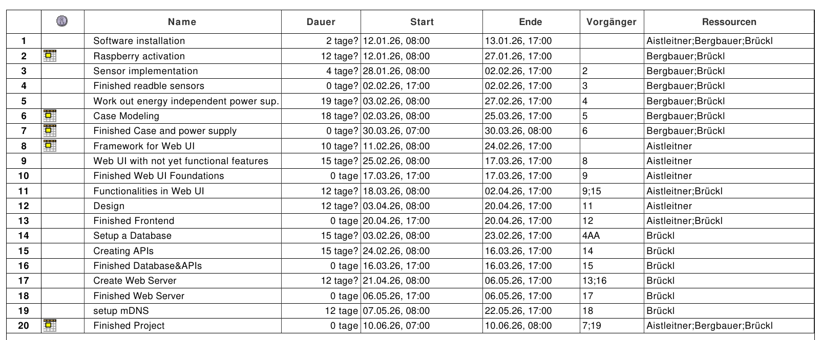
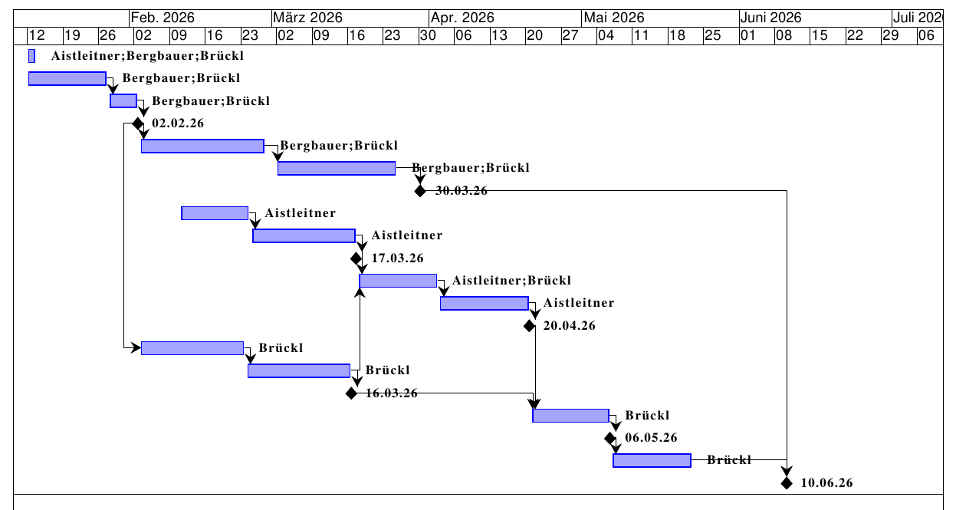

Resource Plan

Wetterstation  001 |  |  | Resource Plan
WBS-Code | Phase/Work-package | Type of resource |  | Planned quantity (days) | Revised quantity (days) | Actual quantity (days) | Deviation  (days)
2 | Raspberry activation | Raspberry Pi Zero 2W, Laptop, Raspberry Pi Imager |  | 12 | 12 | 12 | 0
3 | Sensor implementation | Raspberry Pi Zero 2W, DHT22, BME280 |  | 12 | 12 | 12 | 0
5 | Work out energy independent power supply | Raspberry Pi Zero 2W, Battery, solar panel |  | 15
6 | Case modeling and printing | 3D-Printer, ABS- Filament, Laptop, Oneshape |  | 15
8 | Framework fro Web UI | Laptop, Virtual Studio Code |  | 10
9 | Web UI with not yet functional features | Laptop, Virtual Studio Code |  | 15
11 | Functionalities in Web UI | Laptop, Virtual Studio Code |  | 12
12 | Web UI Design | Laptop, Virtual Studio Code |  | 12
14 | Setup a Database | Laptop, Raspberry Pi Zero 2W, DataGrip |  | 15
15 | Creating APIs | Laptop, Raspberry Pi Zero 2W, Virtual Studio Code |  | 15
17 | Create Web Server | Laptop, Raspberry Pi Zero 2W, Virtual Studio Code |  | 12
19 | Setup mDNS | Laptop, Raspberry Pi Zero 2W, Virtual Studio Code |  | 12

Project Cost Plan

Wetterstation  001 |  | PROJECT COST PLAN
WBS-Code, WP-Title | Type of Cost |  | Planned cost | Revised cost | Actual cost |  | Deviation
 | - Personnel |  | 0€
 | - Material |  | 98€
 | - External services |  | 0€
 | - Other |  | 0€
 | Total |  | 0€
 | - Personnel |  | 0€
 | - Material |  | 0€
 | - External services |  | 0€
 | - Other |  | 0€
 | Total |  | 0€
 | - Personnel |  | 0€
 | - Material |  | 0€
 | - External services |  | 0€
 | - Other |  | 0€
 | Total |  | 0€
Project cost |  |  | 98€

Project Communication

Wetterstation  001 |  | PROJECT-  COMMUNICATION
Title | Objectives, Content |  | Participants | Schedule | Location
Project owner meeting | - project status  - decisions  - acceptance of progress report |  | Project owner,  Project manager | Not yet  scheduled | Teacher  Table
Project controlling meeting | - project status  - controlling of tasks, schedule, resources, costs  - controlling of project environments  - social controlling  - prepare proposal for decision |  | Project manager,  Project team,  Project coach | Every Monday at 11 o clock | Last Row,  classroom  T233
Subteam meeting | - Coordination of subteams  - Discussion of problems |  | Subteam | Every Monday at 11 o clock | Last Row,  classroom  T233

Project „Rules“
Communication:
- Weekly Meetings: The participation of the Project Team Member and the Project Manager in the Weekly Meetings is very important. The meeting is scheduled every Monday at 11 o clock.
- File sharing: All files belonging to the project must be published in the GitHub repository. No other ways to share files are allowed.
- Communication channels: All important information will be published in the team group.
General Collaboration:
- Time Management: Each team member is responsible for their own work packages. These must be completed by the deadline. If more time is needed, this must be requested promptly.
- Support:
  - If help is needed with a work package, it must be requested promptly.
  - If someone needs help and you have the time and are able to help, you are obligated to do so.
Documentation:
- Version Control: The Project Handbook must be updated regularly. Significant changes require a new version number and an entry in the document history.
Technical Standard:
- Hardware Care: Care must be taken with the hardware components, and they must not be damaged or broken in any way. If this happens, the affected part must be replaced.

Project Risk Analysis

 |  | PROJECT RISK ANALYSIS
WBS-  Code | WBS-  description | Risk-  description | Priority | Benefit  /Cost | Probability | Risk-  value | Delay | Avoiding action | Cost for minimizing risk
(Code) | (Text) | (Text) | (Range) | (iuro) | (Percentage) | (iuro) | (iWeeks) | (Text) | (Euro)
2 | Raspberry  activation | break | 1 | 30€ | 10% | 30€ | 1-2Weeks | Take Care | 0€
3 | Senor  implementation | Sensor breaks | 1 | 5-10€ | 10% | 5-10€ | 1-2Weeks | Take Care | 0€
5 | Workout energy  independent supply | Provide not enough  electricity | 2 | 20€ | 20% | 20€ | 1-2Weeks | First Think, than buy | 15€
6 | Case Modeling | Wrong size | 4 | 5€ | 40% | 5€ | ½ Week | Measure correctly | 0€
14 | Setup a Database | Database is too small | 2 | 0€ | 10% | 0€ | ½ Week | Think first about the right size | 0€
15 | Creating APIs | APIs don’t share the data | 5 | 0€ | 15% | 0€ | ½ Week | Have a clear structure | 0€
17 | Create Web Server | The server don’t start | 3 | 0€ | 10% | 0€ | ½ Week | Inform you how to create a  server | 0€
18 | setup mDNS | DNS doesn’t work | 3 | 0€ | 20% | 0€ | ½ Week | Inform you how to setup mDNS | 0€
Project total

Project Documentation

Area | Description
File | In the GitHub Repository: Directory named “Documentation”
Access Authorisation | Everyone from the Project Team has access to the documentation
Naming convention | DDMMYYYY_version_name.docx
Rules

Project Start

Minutes– Project Start

Project Start Workshop

Follow-up Workshop

Project Owner Meeting

Project Co-ordination

Approval of Work-packages
Wetterstation  001 |  | APPROVAL OF  WORK-PACKAGES
WBS-Code | Work-package |  | WP-Owner | Date | Approval by | Signature
2 | Raspberry activation |  | Berbauer K. | 27.01.26 | Brückl M. | Brückl M.
3 | Sensor implementation |  | Berbauer K. | 02.02.26 | Brückl M. | Brückl M.
5 | Work out energy  independent power supply |  | Berbauer K.
6 | Case Modeling |  | Berbauer K.
8 | Framework for Web UI |  | Aistleitner D. | 10.03.26 | Brückl M. | Brückl M.
9 | Web UI with not yet  functional features |  | Aistleitner D.
11 | Functionalities in Web UI |  | Aistleitner D.
12 | Design |  | Aistleitner D.
14 | Setup a Database |  | Brückl M.
15 | Creating APIs |  | Brückl M.
17 | Create Web Server |  | Brückl M.
19 | setup mDNS |  | Brückl M.

Minutes – Project Co-ordination

Project Controlling

Project Status Report
Wetterstation  001 | PROJECT STATUS REPORT  as of Bergbauer Klaus
Project crisis  Project in difficulties  Project according to plan |  | - Overall Status:  - The project is progressing well. Raspberry Pi Zero 2W has been successfully set up with SSH and Wi-Fi enabled. DHT11 sensor testing is underway, and the basic React website structure is complete.
2) Status Project objectives  - Set up Raspberry Pi Zero 2W with OS Lite  - Enable remote access via SSH  - Test DHT11 temperature/humidity sensor  - Develop React-based web interface |  |  | Activities:  - Raspberry Pi successfully configured  - DHT11 sensor integrated and tested (command line output working)  - Basic website structure implemented in React
3) Status Project progress  - Hardware setup: 80% complete (waiting for hardware shipment)  - Sensor integration: 55% complete (testing phase)  - Website development: 20% complete (structure done, output pending) |  |  | Activities:  - Raspberry OS Lite installed on 32GB Micro SD card  - SSH and Wi-Fi connectivity established  - DHT11 sensor displaying data in terminal  - React frontend Framework implemented
4) Status Schedule  - On track - all milestones met by 03.02.2026  - No delays reported |  |  | Activities:  - Phase 1 (Hardware Setup) completed on time (with lend Raspberry)  - WBS 3 (Sensor Testing) in progress as planned
5) Status Resources/costs  - Raspberry Pi Zero 2W (lended)  - 32GB Micro SD card  - DHT11 sensor (for testing)  - DHT22 sensor  - BMP280 |  |  | Activities:  - Nearly all required hardware procured  - Budget within limits  - No additional resource requirements identified
6) Status Context  - Raspberry Pi Imager used for OS installation  - PowerShell used for remote SSH connection |  |  | Activities:  - Documentation of setup procedure completed  - Network connectivity stable  - No external blockers or dependencies
7) Status Organisation/culture  - Author: Klaus Bergbauer  - Collaboration ongoing |  |  | Activities:  - Knowledge sharing via progress documentation  - Testing and development workflow established  - Communication channels functional (SSH, Wi-Fi)

Project Status Report
Wetterstation  001 | PROJECT STATUS REPORT  as of Brückl Matthias
Project crisis  Project in difficulties  Project according to plan |  | - Overall Status:  - The project is progressing well. Raspberry Pi Zero 2W can readout the DHT22 and the BME280 sensors. The first steps towards a database have been taken and the Web User Interface has been optimized.
2) Status Project objectives  - Integrate high-precision sensors (DHT22, BME280)  - Automate data retrieval via scripting  - Improve React frontend design |  |  | Activities:  - DHT22 & BME280 successfully wired and recognized  - Custom script for data reading completed  - UI styling and layout optimization finished
3) Status Project progress  - Hardware setup: 100% (All sensors arrived and installed)  - Data Processing: 90% (Scripts functional)  - Website development: 40% (UI refined) |  |  | Activities:  - Replaced DHT11 with superior DHT22/BME280 sensors  - Developed and debugged data collection script  - Implemented CSS/styling updates to the React WebUI
4) Status Schedule  - On track - all milestones met by 16.02.2026  - No delays reported |  |  | Activities:  - WP 2 (Raspberry activation) completed on time (with lend Raspberry)  - WP 3 (Sensor implementation) completed
5) Status Resources/costs  - Raspberry Pi Zero 2W (lended)  - 32GB Micro SD card  - DHT22 sensor  - BME280 |  |  | Activities:  - Nearly all required hardware procured  - Budget within limits  - No additional resource requirements identified
6) Status Context  - PowerShell used for remote SSH connection  - Python Scripts used to read out the sensors  - data output verified via terminal |  |  | Activities:  - Documented the pinout configuration for the new sensors  - No external blockers or dependencies
7) Status Organisation/culture  - Author: Matthias Brückl  - Collaboration ongoing  - Documentation updated for new hardware |  |  | Activities:  - Knowledge sharing via progress documentation  - Testing and development workflow established  - new Scripts are published to the other Projektmembers

Project Status Report
Wetterstation  001 | PROJECT STATUS REPORT  as of Aistleitner Daniel
Project crisis  Project in difficulties  Project according to plan |  | - Overall Status:  - The project is progressing well. Work on the system architecture has expanded. We have successfully started the database initialization and the independent power concept, necessitating an earlier setup of the web server for performance monitoring.
2) Status Project objectives  - Worked out a concept for an independent power supply  - Write a logging script  - created a web server on the Raspberry Pi |  |  | Activities:  - Concept design for solar/battery power integration  - Development of a logging strategy for system stability  - Initial web server deployment
3) Status Project progress  - WP5 (Work out energy independent power supply) completed  - WP14 (Setup a Database) is 95% finished  - WP9 (Web UI with not yet functional features) is 75% finished |  |  | Activities:  - Research and component selection for the independent power supply  - An Apache Web Server was installed on the Raspberry Pi  - Setup an SQLite Database
4) Status Schedule  - On track  - minimal delays reported  - The web server setup was pulled forward from WP 17 to analyze system load early |  |  | Activities:  - all milestones are almost reached by 11.03.2026
5) Status Resources/costs  - Raspberry Pi Zero 2W (lended)  - 32GB Micro SD card  - DHT22 sensor  - BME280 |  |  | Activities:  - Budget within limits  - Solar panel and batteries are being ordered
6) Status Context  - Used Python for the logging script and SQL to build a database  - Used the Apache services for the web server |  |  | Activities:  - The scripts were documented with comments  - documented all commands for the installation of the web services
7) Status Organisation/culture  - Author: Matthias Brückl  - Collaboration ongoing  - Documentation updated |  |  | Activities:  - Knowledge sharing via progress documentation

Additional Project Status Reports

Minutes – Project controlling

Project Controlling Meetings

Project Owner Meetings

Project Close Down

Project Close Down Report

Wetterstation  001 |  | PROJECT CLOSE DOWN REPORT
- Overall impression |  |  | - Reflection: Fulfilment of objectives
- Reflection: Deliverables / Schedule

- Reflection: Resources / Costs

- Reflection: Internal Organisation / Environmental Relationships

- Performance appraisal (Project owner, Project manager, Project member) |  |  | - Lessons learned (Summary of Experiences and suggestions for improvement)
- Post-Project Phase Planning, Additional Tasks
 | To-Do |  |  | Owner |  | Schedule
- Project Close Down

HTL Wels (Project owner) Brückl Matthias (Project manager)

Minutes – Project Close Down

Project Close Down Workshop

